**Configuration Management (CM)**

There are two types of CM

Pull based CM

Push Based CM

Direction of Communication

PULL => Node to CM server

Push => CM Server to Node

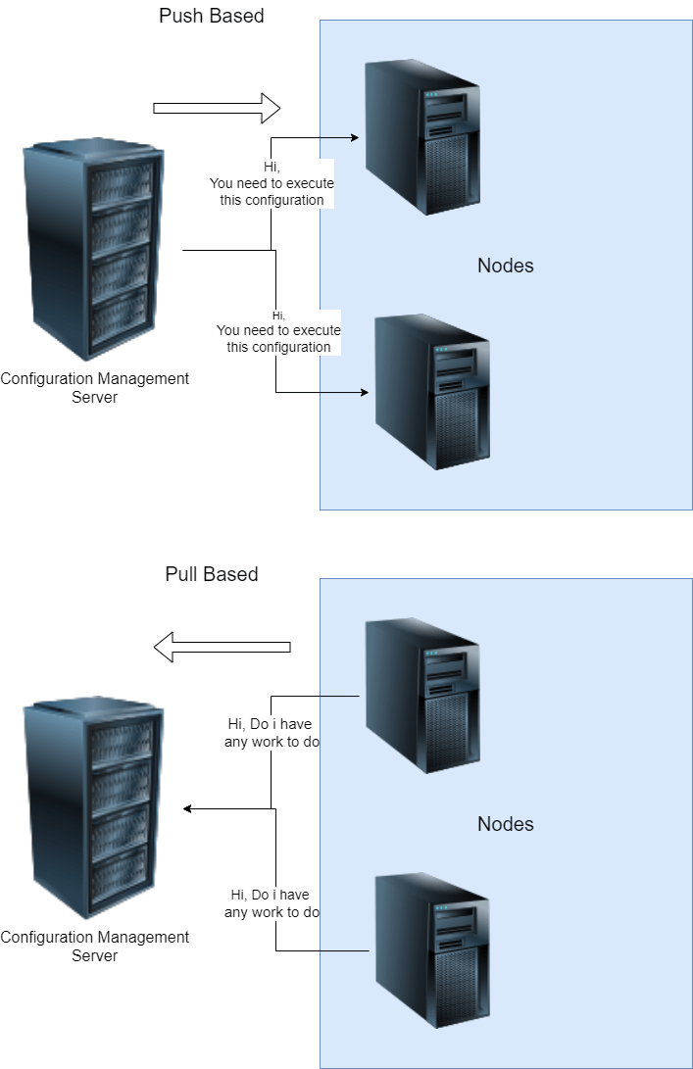

What is required in PULL Based CM?

Agent needs to be installed with necessary credentials to connect to CM Server

What is required in Push Based CM

List of nodes (inventory)

Credentials to login into node  
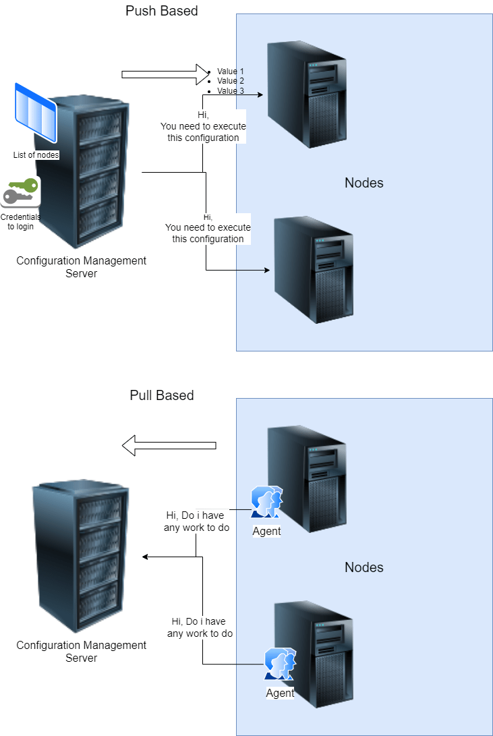

Popular tools

Pull:

Chef

Puppet

Push:

Ansible

SaltStack  
